Elevator Series
Project 1

Objective:
The year is 1900. You are the architect of a new office building in downtown New York. You have been instructed to use the latest technology, such as elevators. Your building is to be a true marvel of the modern world with a whopping twenty-stories and three elevators. This lab should be a simulation of the elevators in the building. The program must read in a file containing a list of people on each floor. (The file represents the distribution of people calling the elevator at the start of an hour.) The information in the file must be read into an appropriate data structure. At the end of an hour, your program must output the distribution of people and the status of each elevator. Your project should be turn based (like the case study) where each “turn” represents one minute. The final project should be a class-based solution. And remember, this is 1900, so renovations are definitely in the future--make sure you have a good foundation to build upon.

Description:
The elevators are used throughout the day, but at different loads at any given time. The usage versus time is shown on the graph below. This shows that, for example, an elevator is more likely to be called at 9 am than at 11 am. The elevators work based on a simple algorithm (not to mention inefficient—it’s 1900, after all). When there is a call, an elevator is sent to take care of the call. The building first deals with the calls closer to the ground (i.e. a call on floor 4 gets dealt with before a call on floor 9) and, if a floor has people going both directions, the down destination gets precedence. Once it has picked up everyone whose destination agrees with the call, the elevator begins moving in the direction indicated by the calling floor. The elevator picks up and drops off people, always moving in the same direction, until it is empty. Once it is empty, the elevator becomes free and begins moving back to the bottom floor, unless there is another call. The elevator moves at a rate of one floor per minute and has a maximum capacity of six people.

Example
Say there is a man, who goes by Joe Bob, working on floor twelve of the building. It’s Friday and he’s eager to go home, so he finishes early and calls the elevator at 5 pm. When he pushes the call button, the building dispatches a non-busy elevator to the twelfth floor from the ground floor (takes 12 minutes to arrive). Once the elevator arrives, not only does Joe Bob get on, but also several other people who want to go down get on. One of them only wants to go to the tenth floor, so the elevator stops there and lets him off (takes 2 minutes), and then continues going down. It next stops at the eighth floor (takes 2 minutes) and picks up more people who want to go down. Again, at the fifth floor, the elevator stops to let people on (takes 3 minutes), but the elevator becomes full after the first one gets on. Thus, the doors slam shut on the remaining people and the elevator moves on. The fifth floor’s call button remains lit, however, and the people on that floor continue to wait. Finally, Joe Bob’s elevator reaches the bottom floor (takes 5 minutes) and releases our man and everyone else on the elevator. The elevator now becomes non-busy again. (Note, if the elevator is not at the ground floor when it becomes non-busy, it should head there, picking up passengers along the way.) And that is how the elevator should run.

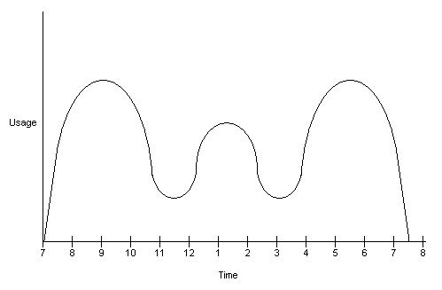

Sample Text File
Calls at 5 pm

Floor
1
2
3
5
5
8
9
9
10
12
14
19

Person
Stephanie
Sanjay
Kyle
Randy
Melissa
Ankur
Jake
Scott
Aaron
Alex
Ben
Stanley

Destination
8
1
1
8
12
1
1
1
3
1
1
1

Sample 10 minute Output
(For 5pm Calls)

Floor 1: 2 person(s): Sanjay, Kyle,
Floor 8: 2 person(s): Randy, Stephanie,
Floor 9: 1 person(s): Jake, Scott,
Floor 10: 1person(s): Aaron,
Floor 12: 1 person(s): Alex,
Floor 14: 1 person(s): Ben,
Floor 19: 1 person(s): Stanley,

RegElevator 1: Floor 11, Destination UP, 1 person(s): Melissa,
RegElevator 2: Floor 7, Destination DOWN, 1 person(s): Ankur,
RegElevator 3: Floor 7, Destination UP, 0 person(s): ,

Elapsed Time: 10 minute(s)

Sample Final Output
(For 5pm Calls)

Floor 1: 8 person(s): Sanjay, Kyle, Ankur, Jake, Scott, Alex, Ben, Stanley,
Floor 3: 1 person(s): Aaron,
Floor 8: 2 person(s): Randy, Stephanie,
Floor 12: 1 person(s): Melissa,

RegElevator 1: Floor 1, Destination NONE, 0 person(s): ,
RegElevator 2: Floor 1, Destination NONE, 0 person(s): ,
RegElevator 3: Floor 1, Destination NONE, 0 person(s): ,

Elapsed Time: 57 minute(s)

